NAME : AMNA SIDDIQUE
SECTION : C
ROLL NO : F24-0759
SUBJECT : OPERATING SYSTEM
SEMESTER : 5th
Introduction
In this lab I practiced navigating the Linux file system using the command line (terminal). I used commands to see my current location, move between directories, and list the contents of different folders. I recorded my whole session using the script command and saved it in session_log.txt, which I uploaded to my GitHub repository.

Task 1: Display your current directory
Command: pwd
Explanation: pwd stands for “print working directory”. It shows the full path of the folder I am currently in. My output was /home/noctisadamkent, which is my home directory.
Task 2: Change to the /etc directory
Command: cd /etc
Explanation: cd stands for “change directory”. This command moved me into the /etc directory, which stores the system’s configuration files.
Task 3: Go to the parent directory of the current directory
Command: cd ..
Explanation: The .. symbol means the parent directory, which is one level above the current folder. Since I was in /etc, this took me up to the root directory /.
Task 4: Go to the root directory
Command: cd /
Explanation: The / symbol is the root directory, the very top of the Linux file system. This command takes me directly to the root from any location.
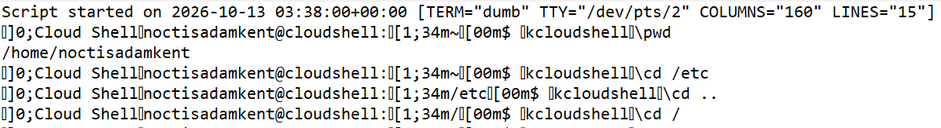

Task 5: List the contents of the root directory
Command: ls
Explanation: ls lists the files and folders inside the current directory. In the root directory it showed system folders such as bin, boot, etc, home, lib, usr and var.
Task 6: Display a long listing of the root directory
Command: ls -l
Explanation: The -l option shows the listing in long format. For each item it displays the permissions, number of links, owner, group, size, date modified and name.

Task 7: Stay where you are and list the contents of /etc
Command: ls /etc
Explanation: When a path is written after ls, it lists the contents of that directory without moving into it. This showed the configuration files and folders inside /etc while I stayed in the root directory.
Task 8: Stay where you are and list the contents of /bin and /sbin
Command: ls /bin /sbin
Explanation: ls can list more than one directory in a single command. /bin contains essential user commands, and /sbin contains system administration commands. The output shows both lists one after the other. (Partial output shown.)
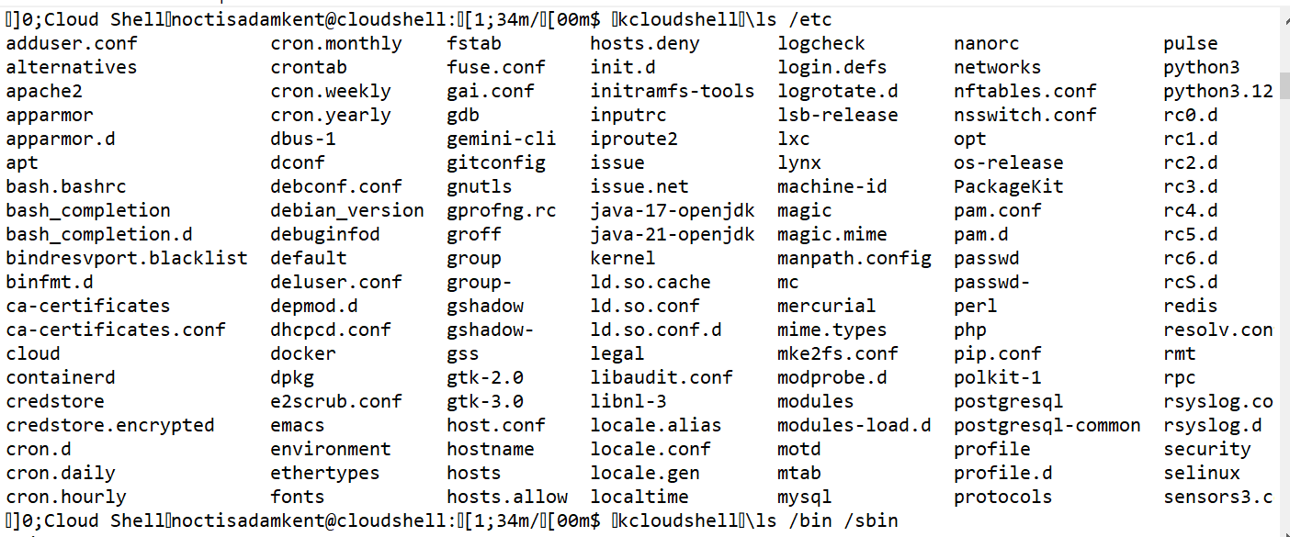

Task 9: Stay where you are and list the contents of ~
Command: ls ~
Explanation: The ~ symbol represents the user’s home directory. This command listed the files in my home directory, which included README-cloudshell.txt and session_log.txt.
Task 10: List all files (including hidden files) in your home directory
Command: ls -a ~
Explanation: The -a option shows all files, including hidden ones. Hidden files have names that start with a dot, such as .bashrc, .profile and .bash_history.
Task 11: List the files in /boot in a human-readable format
Command: ls -lh /boot
Explanation: -l gives the long listing and -h shows file sizes in human-readable units such as KB or MB instead of bytes. The /boot directory was empty, so the output shows total 0.
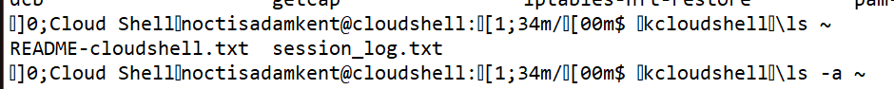

Recording the session
Before starting, I ran TERM=dumb script -q session_log.txt to record all commands and their outputs. After finishing, I typed exit to stop the recording. The file session_log.txt was then downloaded and uploaded to my GitHub repository.
Conclusion
In this lab I learned how to find my current location, move between directories using absolute paths, .. and /, and list directory contents using ls with the options -l, -a and -h. I also learned what the ~ symbol means and how to record a terminal session.
